Call Creation email to Customer:  
  
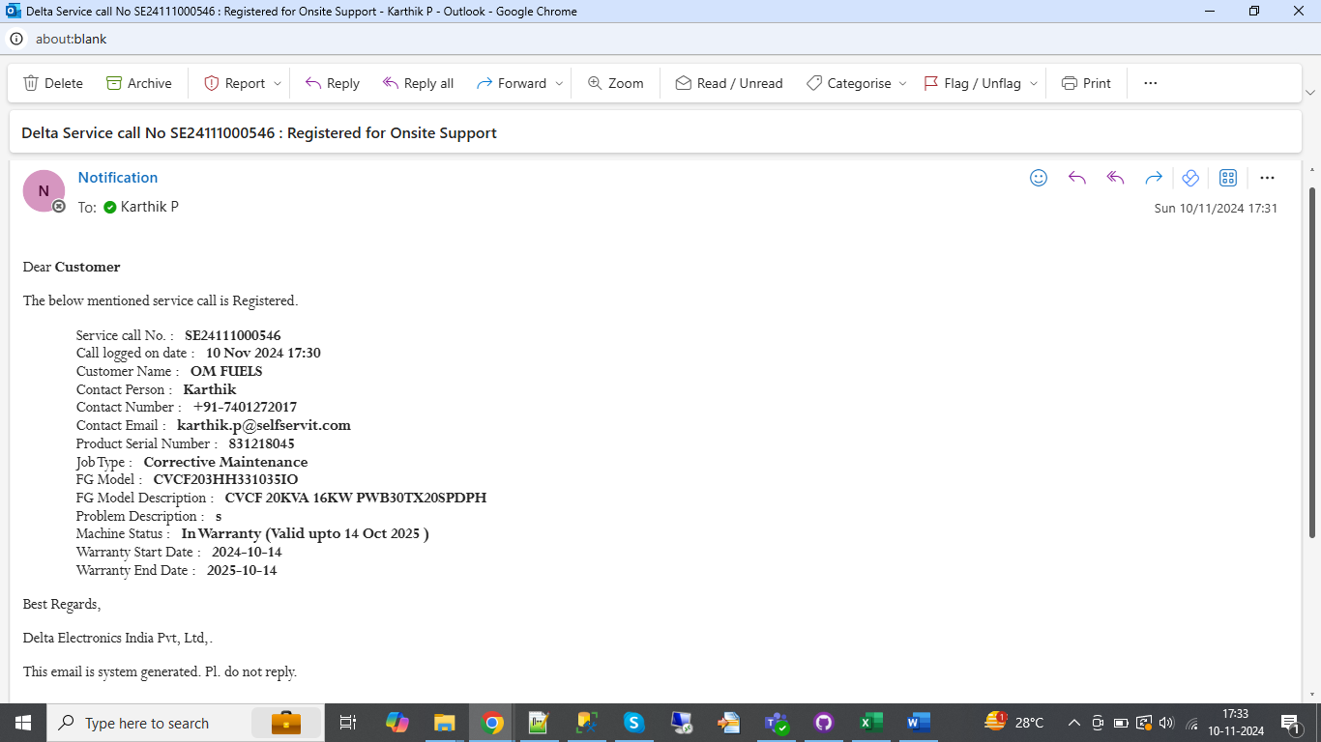  
  
Assign to L2 :  
  
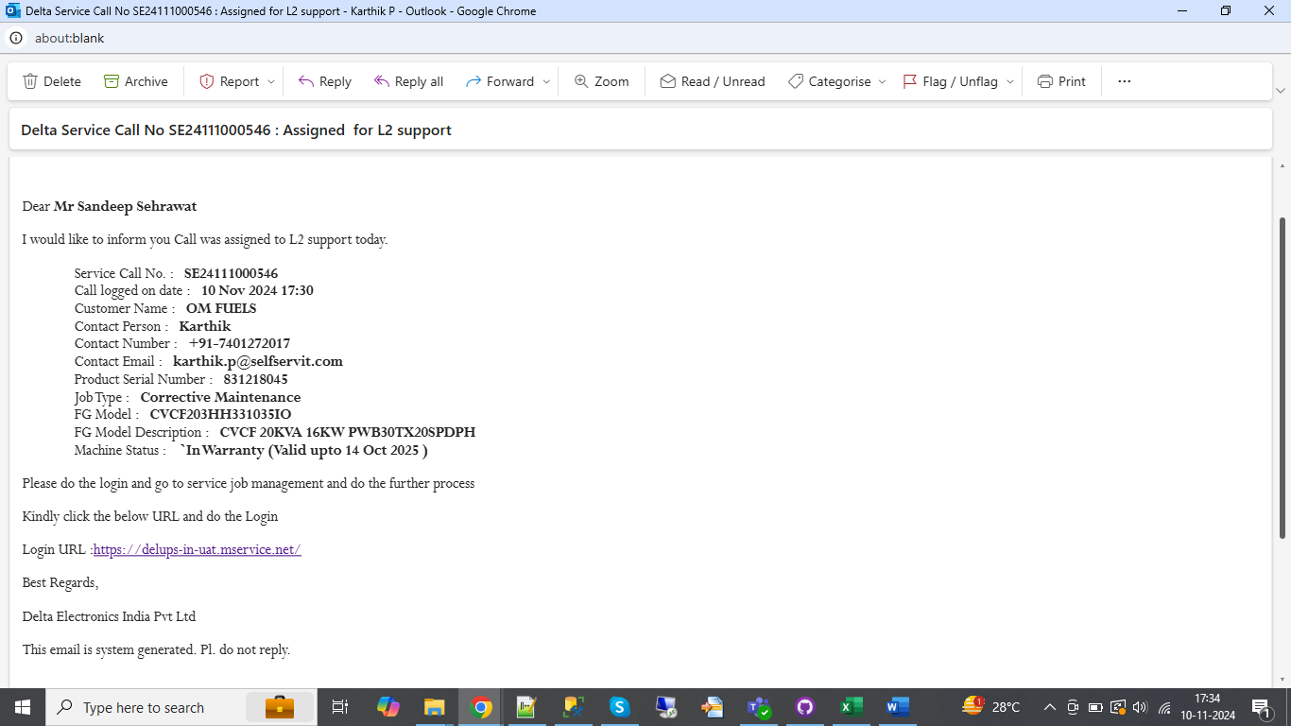

Assign to parts coord:  
  
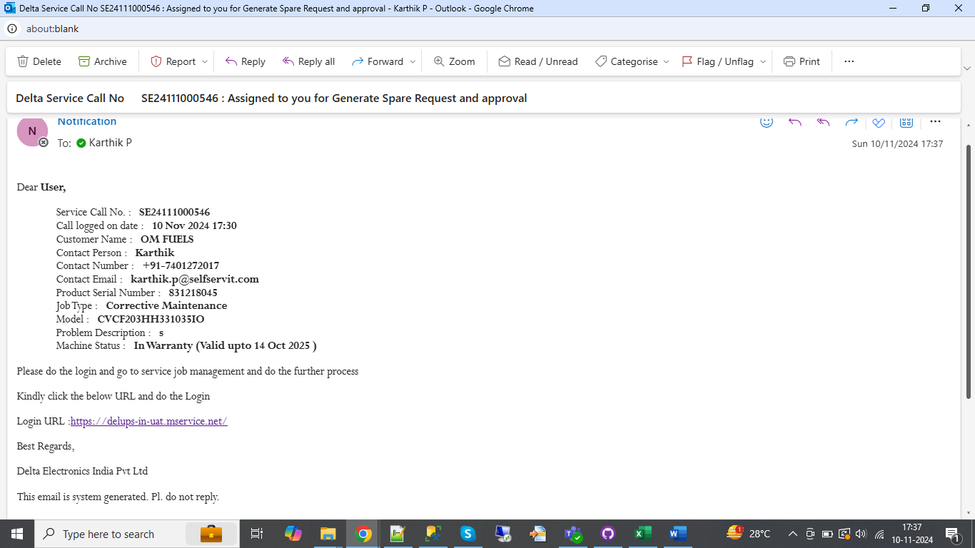  
  
  
Spare Creation :  
  
